Output:

- Write a program for implementing Naive Bayes.
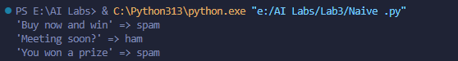

- Write a program for implementing Neural Networks for realization of AND, OR gates.
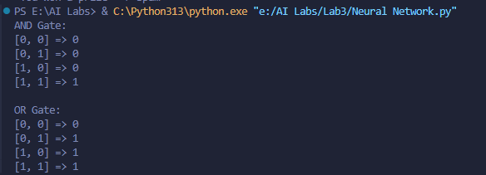

- Write a program for implementing Backpropagation Learning.
